SYSTEM SPECIFICATIONS
RISC-V VeeR EL2 Based Smart Peripheral Control SoC

1. Introduction

1.1 Project Overview
The proposed project, “RISC-V VeeR EL2 Based Smart Peripheral Control SoC,” focuses on the design and RTL-level verification of a peripheral-oriented System-on-Chip based on the VeeR EL2 RV32IMC RISC-V processor. The SoC integrates the VeeR EL2 processor with ICCM, DCCM, an AHB-Lite system interconnect, Programmable Interrupt Controller (PIC), UART, Timer, GPIO, SPI Controller, I²C Controller, and PWM Generator to provide processing, memory, communication, control, and interrupt-handling capabilities.
The processor executes the embedded application and controls the integrated peripherals through memory-mapped registers. SPI and I²C provide communication interfaces for external devices, UART provides a host-computer interface, GPIO provides general-purpose digital control, Timer provides timing functions, and the PWM Generator provides a programmable control waveform.

1.2 Need for the Project
Embedded control systems commonly require a single processing platform to manage several different peripheral interfaces and real-time control functions. When each peripheral is controlled independently, the system can become difficult to integrate and verify because separate interfaces, control registers, interrupt mechanisms, and timing requirements must be handled consistently.
The proposed SoC addresses this need by integrating the processor, memories, system interconnect, interrupt controller, and required peripheral IPs into a common RTL architecture. AHB-Lite provides a structured memory-mapped control path, while the PIC provides centralized interrupt handling. This enables the processor to configure, monitor, and control multiple peripherals using a consistent software-access mechanism.

1.3 Problem Statement
The primary problem addressed by this project is the integration of multiple communication and control peripherals with a RISC-V processor while maintaining a clear and manageable system architecture. The processor must be able to access peripheral registers correctly, receive peripheral events through interrupts, communicate with external devices, and generate deterministic control outputs.
Without a common system interconnect and centralized interrupt mechanism, peripheral integration can lead to complicated control logic, inconsistent register access, and inefficient event handling. The project therefore aims to develop a unified SoC architecture in which processor control, peripheral access, external communication, timing, digital I/O, and interrupt handling are properly organized.

1.4 Proposed Solution
The proposed solution combines the VeeR EL2 RV32IMC RISC-V processor with core-local memories, an AHB-Lite system interconnect, PIC, and multiple peripheral controllers. The processor performs system initialization, peripheral configuration, application processing, data transfers, and interrupt handling.
The VeeR EL2 LSU is used as the AHB-Lite master interface for system-level peripheral access. The interconnect performs address decoding and routes read/write transactions to the selected peripheral. ICCM is used for instruction storage and DCCM is used for processor data storage. The UART, Timer, GPIO, SPI, I²C, and PWM blocks are integrated as memory-mapped peripheral slaves, while their selected events are connected to the PIC for interrupt-driven operation.

1.5 System Architecture
The AHB-Lite system interconnect provides the main control and register-access path between the VeeR EL2 processor and the integrated peripherals. Through this path, the processor can configure and monitor the UART, Timer, GPIO, SPI Controller, I²C Controller, and PWM Generator.
The architecture therefore consists of:
• Control Path: VeeR EL2 → AHB-Lite → Peripheral Registers
• Local Instruction Path: VeeR EL2 IFU ↔ ICCM
• Local Data Path: VeeR EL2 LSU ↔ DCCM
• Interrupt Path: Peripheral Interrupts → PIC → VeeR EL2
• Communication Path: SPI/I²C → External Devices
• Monitoring Path: UART → Host Computer
• Control Output Path: PWM Generator → External Load
• Digital I/O Path: GPIO ↔ External Digital I/O

1.6 Peripheral Control and Communication
The SPI Controller provides a synchronous serial interface for communication with an external SPI-compatible device. The processor configures the SPI controller through memory-mapped control and status registers and the controller manages the serial clock, chip-select, transmit data, and receive data operations.
The I²C Controller provides a two-wire serial interface using SDA and SCL for communication with external I²C-compatible sensors or peripheral devices. The processor configures the controller and accesses its data and status registers through the AHB-Lite interface.
The UART provides serial communication between the SoC and a host computer or serial terminal. The Timer provides programmable timing and can generate an interrupt on expiry. GPIO provides general-purpose digital input/output and can support interrupt-on-change operation. The PWM Generator produces a programmable PWM waveform based on processor-configured period and duty-cycle values.

1.7 Control, Interrupt and Memory Management
The processor uses memory-mapped control and status registers to configure and monitor the integrated peripherals. The AHB-Lite interconnect decodes the processor address and routes each transaction to the appropriate peripheral region.
Peripheral events such as SPI/I²C transfer completion, Timer expiry, GPIO input changes, and selected UART events can generate interrupt requests. The Programmable Interrupt Controller aggregates and prioritizes these interrupt sources and presents the selected interrupt to the VeeR EL2 processor for servicing.
The architecture uses ICCM for instruction storage and DCCM for processor data storage. The peripheral registers are accessed through the AHB-Lite system-bus path. The design therefore separates the core-local memory paths from the system-level peripheral control path while maintaining a unified processor programming model.

1.8 Design Objective and Expected Outcome
The main objective is to develop and verify a complete RTL-based smart peripheral control SoC in which the VeeR EL2 processor provides software control and application processing, while the integrated UART, Timer, GPIO, SPI, I²C, and PWM IP blocks provide communication and control functionality.
Verification will cover processor-to-peripheral AHB-Lite transactions, correct address decoding, peripheral register accesses, SPI transmission and reception, I²C data transfer, UART communication, Timer operation, GPIO behavior, PWM waveform generation, PIC interrupt generation and prioritization, and overall application execution.
The expected outcome is a functional and verified VeeR EL2 based SoC that demonstrates integration of a RISC-V processor, core-local memories, AHB-Lite peripheral control, centralized interrupt handling, multiple communication interfaces, general-purpose I/O, timing, and programmable PWM control within a single RTL design.

2. Block Diagram
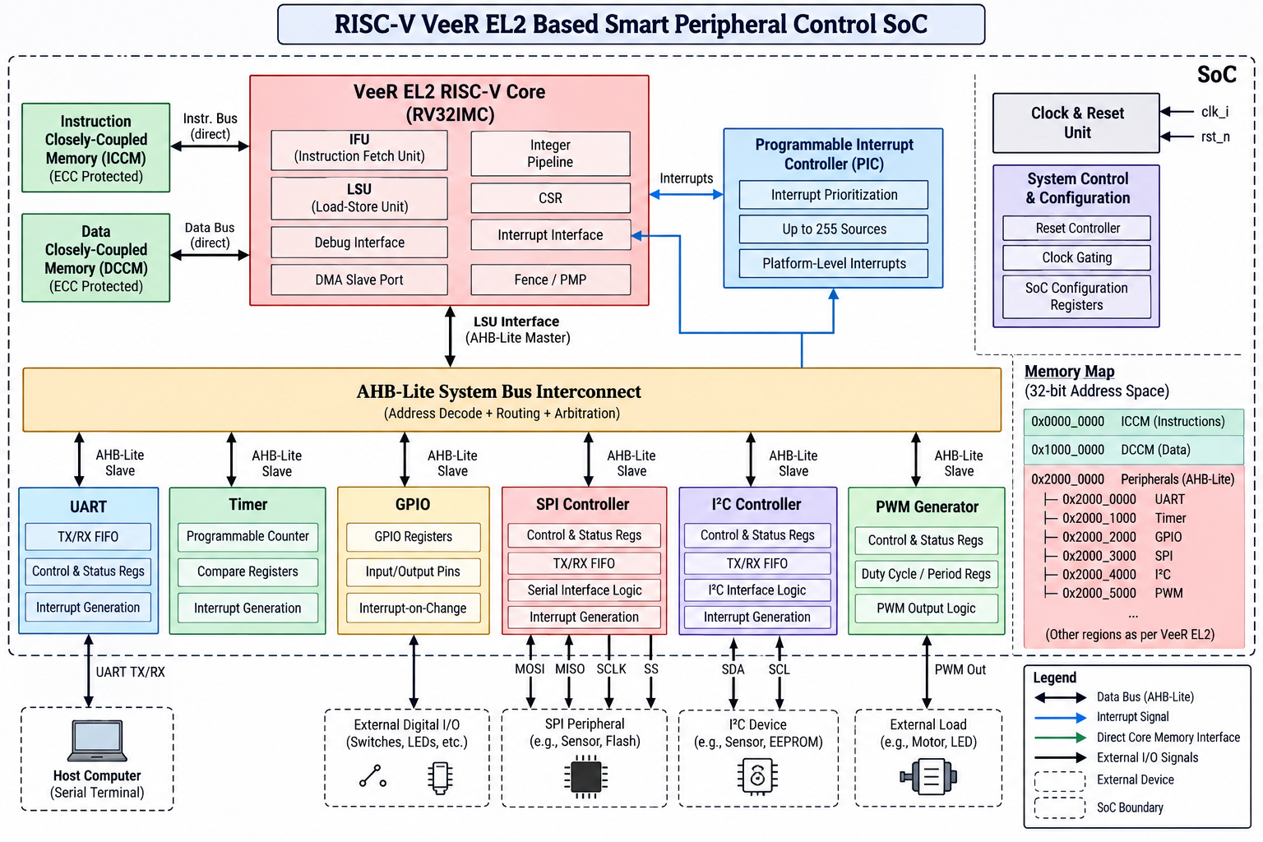
Figure 2.1: Block Diagram of RISC-V VeeR EL2 Based Smart Peripheral Control SoC

3. Signal List
The signal list identifies the major interfaces and external signals shown in the proposed RISC-V VeeR EL2 Based Smart Peripheral Control SoC block diagram. The exact RTL signal names and implementation widths that are not explicitly specified in the architecture are to be finalized during RTL implementation.

3.1 Clock, Reset and System Control Signals
Signal | Direction | Width | Description
clk_i | Input | 1 | System clock input to the Clock & Reset Unit.
rst_n | Input | 1 | Active-low system reset input.
Reset Control | Internal | — | System reset control function shown inside the System Control & Configuration block.
Clock Gating | Internal | — | Clock-gating control function shown inside the System Control & Configuration block.
SoC Configuration Registers | Internal | — | Configuration registers used for SoC-level control.

3.2 VeeR EL2 Core and Memory Interfaces
Interface / Signal | Direction | Width | Description
Instruction Bus | Bidirectional | Implementation-defined | Direct instruction interface between the VeeR EL2 IFU and ICCM.
Data Bus | Bidirectional | Implementation-defined | Direct data interface between the VeeR EL2 LSU and DCCM.
LSU Interface | Bidirectional | AHB-Lite | System-bus interface from the VeeR EL2 Load-Store Unit to the AHB-Lite interconnect.
Interrupts | Input to Core | Implementation-defined | Interrupt interface between the PIC and VeeR EL2 core.

3.3 AHB-Lite System Bus Interconnect Signals
Signal / Group | Direction | Width | Description
AHB-Lite Address | Master → Interconnect/Slave | Implementation-defined | Address for a memory-mapped transaction.
AHB-Lite Write Data | Master → Interconnect/Slave | Implementation-defined | Data associated with a write transaction.
AHB-Lite Read Data | Slave → Interconnect/Master | Implementation-defined | Data returned for a read transaction.
AHB-Lite Transfer Control | Master → Interconnect/Slave | Implementation-defined | Transfer control information used to identify and control the transaction.
AHB-Lite Response | Slave → Interconnect/Master | Implementation-defined | Response/completion information for the transaction.
AHB-Lite Slave Select | Interconnect → Slave | 1 per peripheral | Decoded selection for the addressed peripheral.

3.4 UART Signals
Signal | Direction | Width | Description
UART TX/RX | Bidirectional | 1 + 1 | External UART transmit and receive connections to the host computer/serial terminal.
AHB-Lite Slave Interface | Bidirectional | AHB-Lite | Memory-mapped control and data interface between the interconnect and UART.
TX/RX FIFO | Internal | Implementation-defined | Transmit and receive buffering shown inside the UART block.
Control & Status Registers | Internal | Implementation-defined | Registers used to configure and monitor UART operation.
Interrupt Generation | Output | 1 | UART interrupt source connected to the PIC.

3.5 Timer Signals
Signal | Direction | Width | Description
AHB-Lite Slave Interface | Bidirectional | AHB-Lite | Memory-mapped control and data interface for the Timer.
Programmable Counter | Internal | Implementation-defined | Counter used to implement programmable timing.
Compare Registers | Internal | Implementation-defined | Registers associated with timer comparison.
Interrupt Generation | Output | 1 | Timer interrupt source connected to the PIC.

3.6 GPIO Signals
Signal | Direction | Width | Description
AHB-Lite Slave Interface | Bidirectional | AHB-Lite | Memory-mapped interface for GPIO register access.
GPIO Registers | Internal | Implementation-defined | Control and data registers for GPIO operation.
Input/Output Pins | Inout | N | External general-purpose digital I/O pins.
Interrupt-on-Change | Output | 1 | GPIO event/interrupt source connected to the PIC.

3.7 SPI Controller Signals
Signal | Direction | Width | Description
MOSI | Output | 1 | Master Out, Slave In serial data signal.
MISO | Input | 1 | Master In, Slave Out serial data signal.
SCLK | Output | 1 | SPI serial clock generated by the controller.
SS | Output | 1 | SPI slave-select signal shown in the architecture.
AHB-Lite Slave Interface | Bidirectional | AHB-Lite | Memory-mapped interface for SPI configuration and data access.
Control & Status Registers | Internal | Implementation-defined | SPI control and status registers.
TX/RX FIFO | Internal | Implementation-defined | Transmit and receive buffering.
Serial Interface Logic | Internal | Implementation-defined | Logic responsible for SPI serial transfers.
Interrupt Generation | Output | 1 | SPI interrupt source connected to the PIC.

3.8 I²C Controller Signals
Signal | Direction | Width | Description
SDA | Inout | 1 | I²C serial data line.
SCL | Inout | 1 | I²C serial clock line.
AHB-Lite Slave Interface | Bidirectional | AHB-Lite | Memory-mapped interface for I²C configuration and data access.
Control & Status Registers | Internal | Implementation-defined | I²C control and status registers.
TX/RX FIFO | Internal | Implementation-defined | Transmit and receive buffering.
I²C Interface Logic | Internal | Implementation-defined | Logic responsible for I²C serial transfers.
Interrupt Generation | Output | 1 | I²C interrupt source connected to the PIC.

3.9 PWM Generator Signals
Signal | Direction | Width | Description
PWM Out | Output | 1 | Generated PWM waveform connected to the external load.
AHB-Lite Slave Interface | Bidirectional | AHB-Lite | Memory-mapped interface for PWM configuration.
Control & Status Registers | Internal | Implementation-defined | PWM control and status registers.
Duty Cycle / Period Registers | Internal | Implementation-defined | Registers used to configure PWM duty cycle and period.
PWM Output Logic | Internal | Implementation-defined | Logic that generates the programmed PWM waveform.

3.10 Programmable Interrupt Controller (PIC) Signals
Signal / Group | Direction | Width | Description
Peripheral Interrupt Sources | Input | Multiple | Interrupt requests from UART, Timer, GPIO, SPI and I²C, together with other platform-level sources.
Interrupts to VeeR EL2 | Output | 1 / implementation-defined | Prioritized interrupt indication presented to the VeeR EL2 interrupt interface.
Interrupt Prioritization | Internal | — | PIC function used to prioritize interrupt sources.
Up to 255 Sources | Internal | Up to 255 | Interrupt-source capacity indicated in the architecture.
Platform-Level Interrupts | Input/Processing | Implementation-defined | Platform-level interrupt sources handled by the PIC.

3.11 External Device Interface Signals
External Interface | Signals | Connected To
Host Computer / Serial Terminal | UART TX/RX | UART Controller
External Digital I/O | GPIO input/output pins | GPIO Controller
SPI Peripheral | MOSI, MISO, SCLK, SS | SPI Controller
I²C Device | SDA, SCL | I²C Controller
External Load | PWM Out | PWM Generator

4. Control Path

4.1 Memory-Mapped Register (MMR) Subsystems
The control path of the proposed SoC is based on a memory-mapped register interface. The VeeR EL2 processor accesses the integrated peripherals through their assigned address regions. Control, configuration, status, and data registers are mapped into the processor's 32-bit address space.
The main peripheral register subsystems include UART control and status registers, Timer counter and compare registers, GPIO registers, SPI control/status and TX/RX registers, I²C control/status and TX/RX registers, and PWM control, duty-cycle, and period registers. The processor performs read and write operations to these registers through the AHB-Lite interface.

4.2 AHB-Lite Address Decoding and Access Routing
The VeeR EL2 Load-Store Unit (LSU) acts as the AHB-Lite master for system-level peripheral access. When the processor executes a load or store instruction targeting a peripheral address, the LSU generates the corresponding AHB-Lite transaction.
The AHB-Lite System Bus Interconnect decodes the address and selects the appropriate slave interface. The transaction is then routed to the selected peripheral, where the requested register read or write is performed. Read data and transaction response information are returned through the same AHB-Lite path to the processor.
The memory organization shown in the architecture separates the core-local memories from the peripheral address region. ICCM provides the instruction storage path, DCCM provides the processor's local data storage path, and the peripheral region contains the memory-mapped UART, Timer, GPIO, SPI, I²C, and PWM interfaces.

4.3 Interrupt Control Path
Peripheral events that require processor attention are connected to the Programmable Interrupt Controller (PIC). The UART, Timer, GPIO, SPI Controller, and I²C Controller can generate interrupt requests according to their configured operating conditions.
The PIC collects the interrupt requests, applies interrupt prioritization, and forwards the selected interrupt to the VeeR EL2 interrupt interface. The processor can then execute the corresponding interrupt-service routine and read the peripheral status registers through the normal AHB-Lite control path.

4.4 Peripheral Control Sequence
A typical peripheral-control operation follows the sequence below:
- The VeeR EL2 processor executes an instruction that accesses a peripheral register.
- The LSU generates an AHB-Lite read or write transaction.
- The AHB-Lite interconnect decodes the address and selects the required peripheral.
- The peripheral performs the requested register operation and updates its internal control or status logic.
- If the operation produces an interrupt event, the peripheral asserts its interrupt request to the PIC.
- The PIC prioritizes the interrupt and forwards it to the VeeR EL2 processor.
- The processor services the event and continues application execution.

5. Data Path

5.1 Local Instruction and Data Path
The VeeR EL2 processor uses separate core-local paths for instruction and data access. The Instruction Fetch Unit (IFU) accesses instructions from the Instruction Closely-Coupled Memory (ICCM), while the Load-Store Unit (LSU) accesses the Data Closely-Coupled Memory (DCCM) for local data storage and retrieval.

5.2 Processor-to-Peripheral Data Path
For memory-mapped peripheral operations, the VeeR EL2 LSU generates an AHB-Lite transaction. The transaction passes through the AHB-Lite System Bus Interconnect, where the processor address is decoded and routed to the selected peripheral. For a write operation, the processor-provided data is delivered to the peripheral register or data interface. For a read operation, the selected peripheral returns the requested data through the AHB-Lite interconnect to the LSU.

5.3 Peripheral Data Transfer Paths
The communication peripherals provide the data paths between the SoC and external devices. The UART transfers serial data between the SoC and a host computer or serial terminal. The SPI Controller transfers data through MOSI and MISO with SCLK and SS control. The I²C Controller transfers data through the SDA and SCL lines. GPIO transfers digital input and output values through its external pins, while the PWM Generator produces the programmed PWM waveform.

5.4 Interrupt-Related Data Flow
Peripheral status information associated with an event is available through the corresponding memory-mapped status registers. When a peripheral generates an interrupt request, the request is sent to the PIC. The PIC prioritizes the interrupt and signals the VeeR EL2 processor. The processor then accesses the relevant peripheral status or data registers through the AHB-Lite control path to determine and service the event.

5.5 Overall Data Flow
The overall data movement in the SoC can be summarized as follows:
- Instruction execution: ICCM → VeeR EL2 IFU → Processor
- Local data access: VeeR EL2 LSU ↔ DCCM
- Peripheral write: VeeR EL2 LSU → AHB-Lite Interconnect → Selected Peripheral
- Peripheral read: Selected Peripheral → AHB-Lite Interconnect → VeeR EL2 LSU
- External communication: UART/SPI/I²C ↔ External Device or Host
- Digital control: GPIO ↔ External Digital I/O
- Programmable control output: PWM Generator → External Load
- Interrupt event: Peripheral → PIC → VeeR EL2

